***BEEE EVALUATION***

**Aim:**

**Design a system for a red colored magical heart pendant that blinks 60 times a minute and stops blinking and turns blue during night.**

**Apparatus used:**

Arduino, breadboard, connecting wires, LDR, resistor, LED.

**Principle used:**

**LDR** works on the **principle** of photo conductivity. It is nothing but, when the light falls on its surface, then the material conductivity reduces and also the electrons in the valence band of the device are excited to the conduction band.

**Circuit Diagram:**

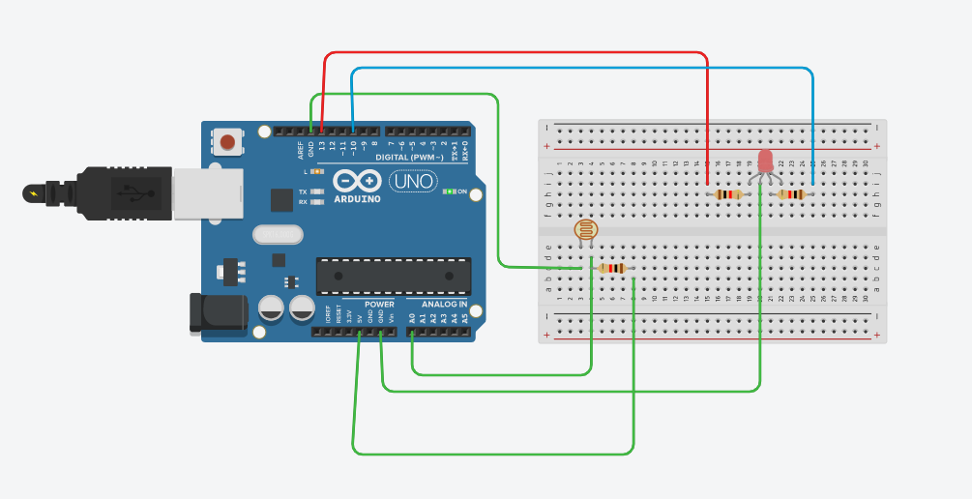

**Precautions used:**

1. Always use the arduino without plugging it.
2. Don’t touch the energized wires and equipments.

**Source Code:**

**void setup()**

**{**

**Serial.begin(9600);**

**pinMode(13, OUTPUT);**

**pinMode(10,OUTPUT);**

**}**

**void loop()**

**{**

**int i;**

**int s=analogRead(A0);**

**Serial.println(s);**

**for(i=0;i<=60;i++)**

**{**

**if(s>250)**

**{**

**digitalWrite(13,HIGH);**

**delay(1000);**

**digitalWrite(13,LOW);**

**delay(1000);**

**}**

**else if(s<250)**

**{**

**digitalWrite(13,LOW);**

**}**

**else**

**{**

**digitalWrite(10,HIGH);**

**delay(1000);**

**digitalWrite(10,LOW);**

**delay(1000);**

**}**

**}**

**}**

**Problems faced:**

1. Connecting the equipments in right phases.
2. Problem faced in uploading the code to the board.
3. Errors in source code.

**Solutions to problems faced:**

1. By connecting the anode of the LED to the ground.
2. Correcting the loops initialisation.